
BCA News 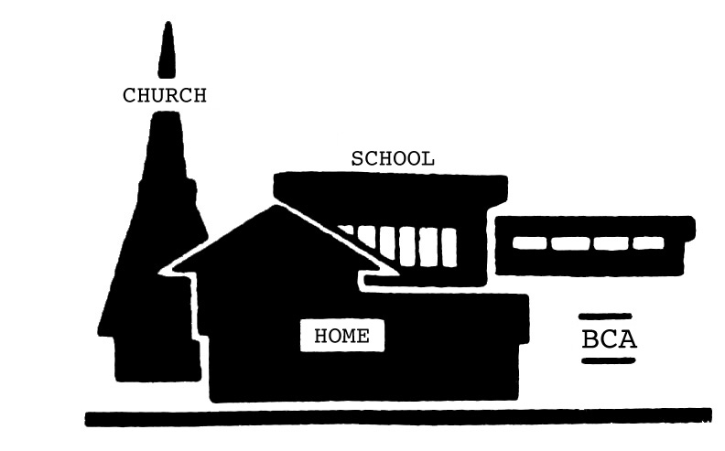
Bayberry Community Association, Inc. April 2010 volume 47 #6

Message from the President

www.bayberrycommunity.org
Noteworthy:
BCA Meetings:
5/2 (John Dougherty and Damian Ulatowski have been invited to talk about Town of Clay issues- All members are invited to attend, express concerns and vote)
Last meeting - 6/6 Meetings are held at 7:00 at the UCC Church
DUES are being collected. Look for your rep and pay your $5 dues today!

Events:
Town Spring Pick-up begins week of May 10. For a collection notice, call 374-8005. townofclay.org

Bayberry Garage Sale - 5/15 (9:00-4:00)
Volunteer Appreciation Event – Sunday 5/16
Rabies Clinics:
Mon. 5/3 (5-7PM) Clay Highway Garage
Tues., 5/25 (6-8PM) SPCA Mattydale
Mon., 6/28 (5-7PM) Cicero Highway Garage

Visit our Website at www.bayberrycommunity.org

I am encouraging all our members to get involved with our community association. Your time could be well spent volunteering for one of the officer positions, Rep-at- Large, our brand new media committee, or as a representative in your area. Get together with your neighbors to plan or attend one of our activities. All members are welcome at all of our meetings. Your input, your time, and your expertise are greatly needed and would be appreciated. Please contact me anytime at home 622-0189, email dmd26@verizon.net or on the contact page of our website: www.bayberrycommunity.org.
Bayberry Garage Sale 5/15
On Saturday, May 15, Bayberry will host our annual garage sale. Start your spring cleaning and empty out those attics, basements & garages for the biggest garage sale event in Liverpool. The Bayberry Plaza marquee will announce the sale. We will be adding new signs to ALL the main and secondary entrances on both sides of Rte 57 and the east entrances of Bayberry along John Glenn. We have newspaper, cable and Internet advertising. Sign up and don’t be left out to make a few dollars! Sign up today! Register by May 8th: Please fill out the registration form in the newsletter and send to Susan Williams 234 Blackberry Road or email: sfw8784@yahoo.com. Registering will get you on a list given to people coming to the sale. Sellers may come to Kinney Drugs in the Plaza from 8am to 9:30 am the day of the sale to pick up balloons, signs, maps and lists of participants. Buyers will pick up maps and lists. Sellers please bring your 2010/2011 BCA membership card or you may pay your dues at that time.
Bayberry Volunteer Appreciation Event
On Sunday, May 16, from 4 to 7pm, Bayberry residents are invited to celebrate our volunteers at Megan Mac Murphy’s Restaurant on Oswego Road (Route 57, Ace Hardware Plaza-across from Seneca Mall)
We take time out to say THANK YOU and enjoy a few hours with all the Community Spirited Volunteers who so generously give their time and talent throughout the year to bring activities and other services to Bayberry. Come join us for conversation and refreshments and meet your neighbors. Please contact Mike Banks, 652-2657 or email mbanks2321@aol.com and let us know how many are coming.
The BCA would like to congratulate the following families for participating in the annual snow-sculpting contest. All three will receive a gift card to Liverpool Pizzeria for their effort and enthusiasm. The Dolan Family, the Moen Family and the Turverey Family. Thank you to Jason Nash, owner of Liverpool Pizzeria for his generousity!

BCA Book-a-thon
If You Don’t Sell it – Donate It: During the Bayberry Community Association Garage Sale May 15, if you have books (soft & hard back), DVD’s, cd’s that you were unable to sell – donate to our Liverpool Public Library with our book drive. A donation receipt will be provided for your tax records.
Restrictions for donation: must be good condition – no writing or torn pages & covers, no school text or reference books and no magazines please. Thank you for contributing to your local library. To arrange pick up, please contact Susan Williams, 409-4488 or drop off at 234 Blackberry Road.
School News
Petitions Available for School Board Positions
Five terms of office on the Liverpool Central School District Board of Education will expire on June 30, 2010. Successors to three of these offices will be elected to three-year terms, effective July 1, 2010, through June 30, 2013, at the annual school district election on May 18, 2010. The successors to the remaining two offices will be elected to one-year terms, effective July 1, 2010, through June 30, 2011. Donald Cook, Donna Marsh O’Connor, Patricia Mouton*, Michael Murphy and Joseph Unangst currently hold these Board seats. Board of Education vacancies are not considered to be separate specific offices. The nominating petition does not describe a specific vacancy for which the candidate is being nominated. Each petition is considered for a seat on the Board of Education as a whole and not as applicable only to a specific office presently held by a particular individual. Candidates may be nominated only by petition. Each nominating petition shall be filed with the Office of the District Clerk, in Room 9 of the District Office, 195 Blackberry Road, no later than 5 p.m. on Monday, April 19, 2010. Petition forms to nominate candidates for election to the Board of Education are available in the Office of the District Clerk, located in Room 9 of the District Office. Each nominating petition must state the name and residence of the candidate and be signed by at least 60 qualified voters of the school district. For additional information about Board of Education membership, contact the Office of the District Clerk at 315-622-7130. *Bayberry was saddened by the loss of Pat Mouton. Her dedication for our community was an inspiration!
Bayberry News
+Thank you to Deborah Kratz who will be delivering the NEWS in Area DD. We still need an Area Rep or people willing to deliver our News in Area D, which includes Huckleberry, Ilex, and two homes on Blueberry (thank you to Patrick O’Toole who has been delivering the BCA News in this area). We also need someone for Area Y, which includes some of Arencrest, Behling, and McIntosh (thank you to Bev Kenyon-Haase who delivered last month). >>>>>>>>>>>>>>>>>>>>>>>>>>>>>>
+We are looking for door prizes to award our volunteers this year at our Volunteer Appreciation Event, Sun., May 16th. If you have a business or service and would like to donate anything - nothing is too small to make this event special for our volunteers. Contact Larry Sequin 622-1295 or Mike Banks 652-2657. You will receive recognition in our newsletter, the program and a receipt for your taxes. Thank you for helping us provide a fun & memorable event for our volunteers. >>>>>>>>>>
+Congratulations to Anna Eckardt, Schafer Eckardt, Kyle Richardson, and Joey Dolan who completed the YMCA’s Healthy Kids Day Triathlon on 4/10.
>>>>>>>>>>>>>>>>>>>>>>>>>>>>>>>>>>>>>
+There was a Town Board meeting on 4/19 and an application was considered from Panera Bread for a drive-thru at their bakery on Route 31. They were directed to address safety concerns due to the flow of traffic. Several residents were present to speak against a zone change from R-10 residential to O-2 Office district on 3+ acres located on Buckley Road.
Bayberry Bicyclists
Let’s keep our children SAFE! Here is a summary of the laws that apply to our youth. If you are under 14 years of age, bicyclists are required to wear approved bicycle helmets when they are operators or passengers on bicycles. Child passengers one through four years of age must wear approved bicycle helmets and ride in a specially designed child safety seat. Children under the age of one are prohibited from being transported on a bicycle. In-line skaters under the age of 14 are required to wear approved bicycle helmets. If you are under 14 years old, you are required to wear certified bicycle helmets when riding a non-motorized scooter and when operating a skateboard. Any parent or guardian whose child violates the helmet law is subject to a fine of up to $50. Wear your helmet!
Bayberry Gardens
It’s time for springtime planting in the entrance median again. If you would like to help our Bayberry Gardeners, please call Debbie to volunteer (622-0189). The planting will take place sometime at the end of May.
Nominations
The Bayberry Community Association has accepted nominations for officers: President, 1st Vice President, 2nd Vice President, Secretary and Treasurer. Here are biographical sketches of our candidates.
President: Debbie Magaro-Dolan - I grew up in Liverpool and when my husband and I got married we decided to buy a house close to our childhood homes to raise our kids. I have been involved with the BCA for over 9 years as a rep and officer.
1st VP: Susan Williams – An active BCA member and resident interested in beautifying our community, Susan will work hard to make our community better.
2nd VP: Ivan Andreev – I have been a resident of Bayberry for 5 years in BCA. Currently I am working in banking at AmeriCU Credit Union. I have a MS in Finance from SWU and a degree in Hotel & Restaurant Management.
Treasurer: Diane Benedetto – I am a lifelong resident of Liverpool. As an accounting graduate from LeMoyne, I am a CPA and work at National Grid. I believe it is my social responsibility to give back to my community.
Secretary: Beverly Kenyon-Haase - Twenty-six years ago my husband and I moved to Bayberry to raise a family. When our children were young I was involved with CCE activities, was a Girl Scout leader for 8 years. I was acting Secretary this year.
Earth Day
On Earth Day 2010, a hearty group of six community volunteers, despite the cool, damp weather, met at the Bayberry Plaza to spruce up the neighborhood. Route 57 from Maryland to John Glenn, Bayberry interior areas and much of John Glenn Blvd were cleaned. Participating were Joe McMullen, Larry Seguin, Jordan Curtis, Ivan Andreev and Bob & Joanne Stella. Ted Jarosz picked up a portion of John Glenn a few days before... in much better weather I assume... As usual, Art Dreher from the Town of Clay Highway Dept was on hand to haul away the debris.
Open Houses
1) Saturday, May 15th come to the UCC Nursery School Open House. From 9am -4pm you can learn about our program, tour our facility, meet the teachers and have some fun! We are located at 215 Blackberry Rd. in Liverpool. Please call for more information or to register your child for Fall 2010 classes.
2) The NOVA Open House will be kicking off E.M.S. week on Saturday May 15, 2010 from 11:00 am to 3:00 pm. The event will be held at NOVA’s ambulance building located at 4425 Buckley Road. We will be having many activities including tours of the ambulances, free blood pressure screening, child ID and fingerprinting done by the Sheriff’s department. NOVA, Moyers Corners and Clay Fire Department members will present demonstrations and displays. Meet your local E.M.S. providers and our E.M.S. explorers. The event is free and open to the public. Call 415-8147 for more information.

---------------------------------------------------------------------------------------------------------------------------------------------------
Garage Sale Registration form:

Name: ____________________________________________ Phone: _____________________Area: ____________

Address: ______________________________________________________________________________________

List 5 of your best items for sale.

Send form to Susan Williams at 234 Blackberry Road or sfw8784@yahoo.com

BCA Ballot

Please vote for BCA Officers. Completed ballots with a return address should be mailed to Beverly Kenyon-Haase at 10 Appletree by May 2. Write in votes may be recorded here:

President: ____Debbie Magaro-Dolan
1stVP: ____Susan Williams
2nd VP: ____Ivan Andreev
Treasurer: ____Diane Benedetto
Secretary: ____Beverly Kenyon-Haase

